H.T No
Regulations:
A19

Sreenidhi Institute of Science and Technology
(An Autonomous Institution)
Code No: 7P261 Date: 21-Sept-2022 (FN)

M.Tech I-Year II-Semester External Examination, Sept/Oct-2022 (Supplementary)
ARTIFICIAL INTELLIGENCE & DEEP LEARNING (CSE and CS)

Time: 3 Hours Max.Marks:70

Note: a) No additional answer sheets will be provided.
b) All sub-parts of a question must be answered at one place only, otherwise it will not be valued.
c) Missing data can be assumed suitably.

ANSWER ANY FIVE QUESTIONS. EACH QUESTION CARRIES 14 MARKS.

Bloom's Cognitive Levels of Learning (BCLL)
Remember | L1 | Apply | L3 | Evaluate | L5
Understand | L2 | Analyze | L4 | Create | L6

 |  |  | BCLL | CO(s) | Marks
1. | a) | What is the structure of Intelligent Agent? Discuss the various types of agent programs. | L2 | CO1 | [7M]
 | b) | Write short notes on classical planning problem. | L1 | CO1 | [7M]
2. | a) | Write and explain A* Algorithm with an example. “A* is admissible” justify the statement. | L2 | CO2 | [7M]
 | b) | Explain Alpha-Beta pruning with suitable example. | L1 | CO2 | [7M]
3. | a) | Explain the predicate logic representation with a suitable example. | L2 | CO3 | [7M]
 | b) | Discuss issues in Knowledge representation. | L1 | CO3 | [7M]
4. | a) | In the following cyclic MDP calculate Q(p,A) where C(a)=4 , C(b)=9 C(c)=1  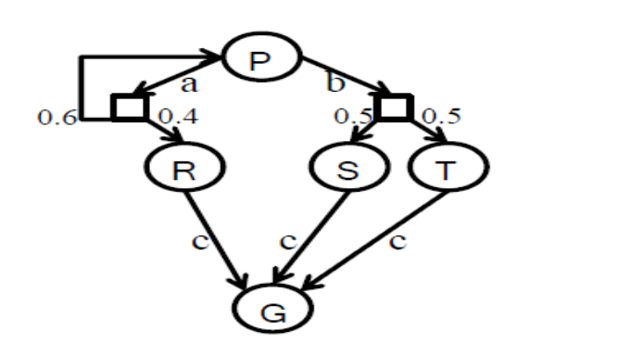 | L5 | CO4 | [7M]
 | b) | Describe the role of probability theory in AI | L1 | CO4 | [7M]
5. | a) | Write about shortcomings of feature selection. | L1 | CO5 | [7M]
 | b) | Draw and explain the architecture diagram of CNN. | L2 | CO5 | [7M]
6. | a) | What is Markov Decision Process? Explain with an example. | L1 | CO6 | [7M]
 | b) | Write about Q Learning. | L2 | CO6 | [7M]
7. | a) | Discuss types of environments. | L1 | CO1 | [5M]
 | b) | What are constraint satisfaction problems? | L2 | CO2 | [5M]
 | c) | Convert the formula (~A → B) ∧ (C ∧ ~A) into its equivalent CNF representation. | L3 |  | [4M]
8. | a) | Explain utility function. | L1 | CO4 | [5M]
 | b) | List the objectives of MDP. | L1 | CO5 | [5M]
 | c) | Write about pole cart. | L1 | CO6 | [4M]
-- 00 -- 00 –

